REG NO: 192210051
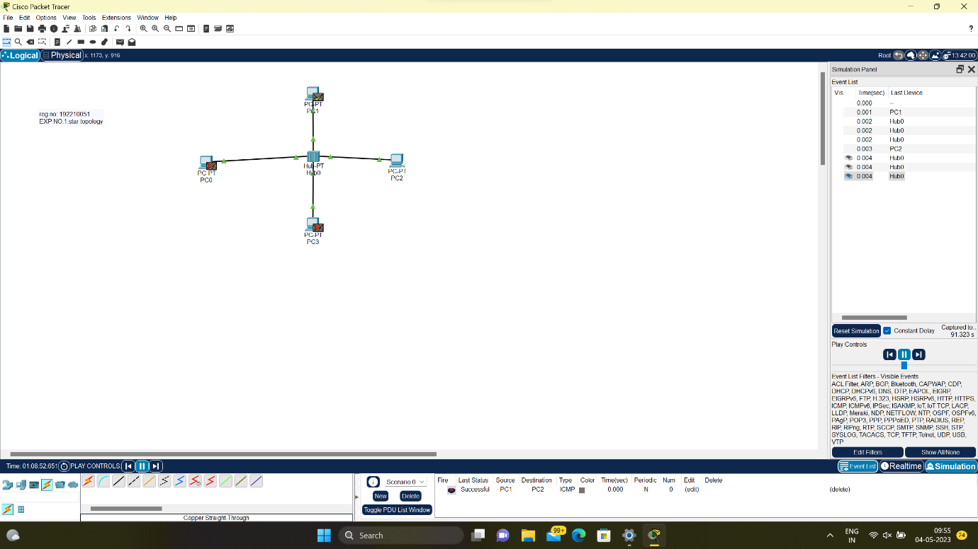
EXPERIMENT 01

STAR TOPOLOGY
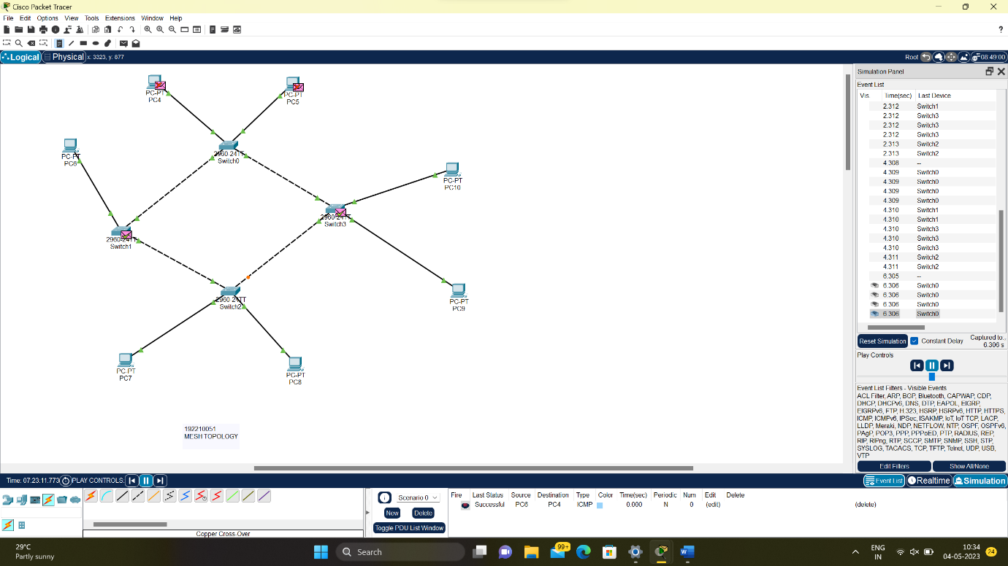
MESH TOPOLOGY
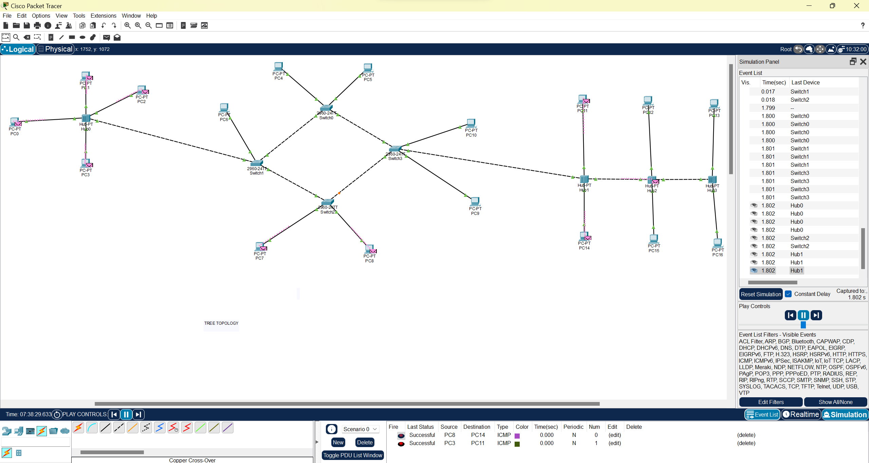
HYBRID TOPOLOGY

